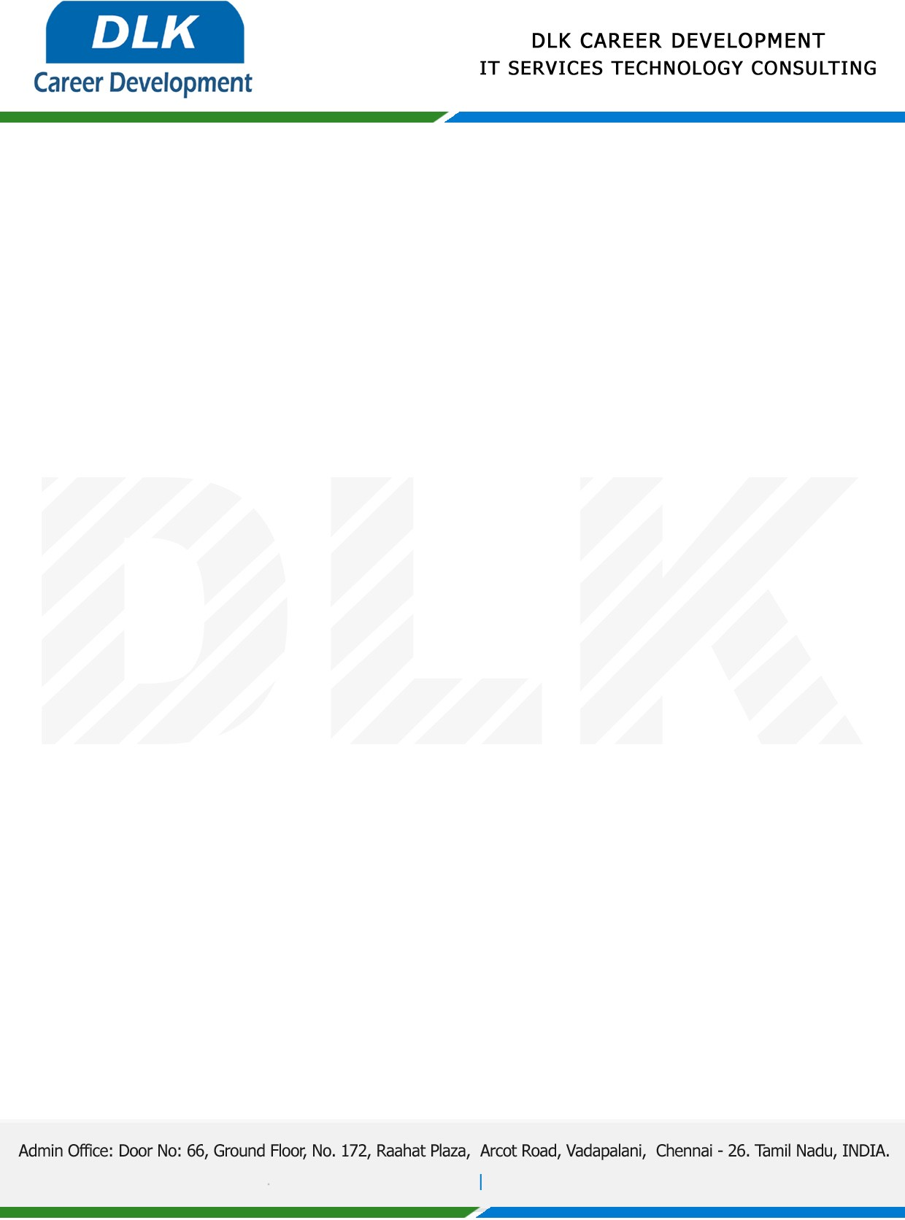

**Date: 02/ March /2023**

**SUB: PROJECT COMPLETION CERTIFICATE**

This is to certify that **MR DHINESH B (REG NO:** **212000069) MSC- Computer Science,** final year student **Jaya College of Arts and Science, Chennai** has Successfully Completed the Project Work under the domain of “**Java”** in our organization during the Period **(01st January 2023** to **28th February 2023).**

**Topic:** A Cloud Secure Storage Mechanism Based on Data Dispersion and Encryption

We appreciate your interest in **DLK CAREER DEVELOPMENT**

**“Best Wishes for Your Future Endeavors “**

